Dropout vs Academic Success in Undergraduate Studies

Anjalee Nair, Charlize Tran, Ethan Harte, Kristina Wong, Jessica Sanchez

University of Houston
MATH 4322
Cathy Poliak
November 2024

Introduction
Our team decided to create a model investigating the impact of social and economic factors on undergraduate students’ dropout and academic success. Our data is sourced from the Kaggle website, which has data from a higher education institution obtained from various disjoint databases relating to individuals enrolled in various undergraduate degrees. The data consists of 35 predictor variables and our response variable is whether a student drops out or not. Since we had several predictors, we decided to clean our data and reduce it to 16 predictors listed below.
Description of Variables:
- Column 1: Marital Status
- Column 2: Application Mode
- Column 3: Application Order
- Column 4: Course
- Column 5: Daytime evening attendance
- Column 6: Previous qualification
- Column 7: Mother’s qualification
- Column 8: Mother’s occupation
- Column 9: Displaced
- Column 10: Debtor
- Column 11: Tuition fees up to date
- Column 12: Gender
- Column 13: Scholarship holder
- Column 14: Age at enrollment
- Column 15: Curricular units 1st semester enrolled
- Column 16: Curricular units 2nd semester enrolled

The goal is to create a model that will accurately answer the following questions: How can we effectively classify undergraduate students' dropout versus academic success rates using our selected predictor variables?

Random Forest
The random forest method in R involves incorporating multiple decision trees to improve prediction accuracy. It enhances bagging by providing slight adjustments that cause decorrelation between trees, which helps prevent a variable from dominating trees. The reason why we decided to use random forests is because it prevents overfitting, and can handle both numerical and categorical data. In our case, we are using Random Forest to predict the Target variable from our dataset, which indicates Dropout or Non-Dropout based on the other predictors. This approach is particularly effective as it can capture complex relationships between predictors such as student characteristics (ex. Age, previous qualifications, etc.) and the outcome variable. Additionally, by evaluating the importance of each feature, Random Forest helps us identify the most influential variables affecting the Target variable, providing insights into what factors contribute to student success or failure. This method ensures a more accurate and robust prediction compared to traditional models.
We begin by creating a preliminary random forest with all 16 predictors shown in the R code below.
> prelim.rf <- randomForest(Target ~ ., data = students, mtry = sqrt(16), importance = TRUE)
>
> prelim.rf

Call:
randomForest(formula = Target ~ ., data = students, mtry = sqrt(16), importance = TRUE)
Type of random forest: classification
Number of trees: 500
No. of variables tried at each split: 4

OOB estimate of error rate: 21.63%
Confusion matrix:
Dropout Non-Dropout class.error
Dropout 751 670 0.4714989
Non-Dropout 287 2716 0.0955711
> varImpPlot(prelim.rf, sort = TRUE, main = NA
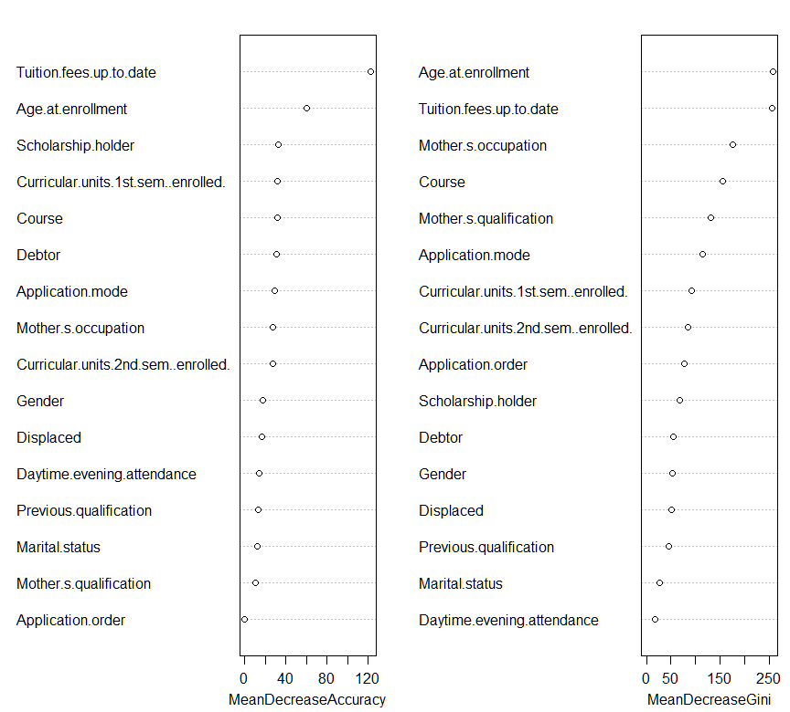

This first model consists of 500 trees and has an OOB (out-of-bag) error rate of 21.63%, which indicates the accuracy derived from the training process based on the data not used in the training of each tree. This means the model correctly classifies 78.37% of the instances. Based on the confusion matrix, Dropout has an error rate of 47.15% and Non-Dropout has an error rate of 9.56%, indicating Dropout class has a much higher misclassification rate than its counterpart. Based on the OOB error rate and the high Dropout error rate, we needed to revise our model by removing irrelevant variables.
The varImpPlot() helps us visualize which predictors contribute to the model prediction or outcome of the response variable. The mean decrease accuracy plot showcases how much the accuracy of the model declines whenever a variable is omitted. The bigger the decline, or the bigger the mean decrease accuracy is based on the plot, the more important a variable is. From our model, it appears that Tuition.fees.up.to.date, Age.at.enrollment, Scholarship.holder, and debtor seem to have the greater impact on the model accuracy, while Previous.qualification, Marital.status, Mother.s.qualification, and Application seem to have the least impact on the model accuracy since these variables are at the very bottom of our plot. Meanwhile, the mean decrease in the Gini coefficient is determined by the mean decrease in the Gini Index whenever the tree splits on a certain variable. The bigger the mean decrease score, the more important a variable is. The given model shows that Age.at.enrollment, Tuition.fees.up.to.date, Mother.s.occupation have significant importance on our model accuracy, while Displaced, Previous.qualification, Marital.status, and Daytime.evening.attendance have the least importance on our model accuracy.
As a result of looking at both plots, it appears that Tuition.fees.up.to.date and Age.at.enrollment is highly significant to the random forest model since the predictors are ranked highly and therefore will be incorporated in the model. At the same time, marital.status, previous.qualification, displaced, and Daytime.evening. attendance. have very little significance to the random forest model because they were the lowest performing predictors on both the mean decrease in accuracy approach and the mean decrease in the Gini coefficient approach.

Neural Networks
Neural networks are a powerful tool for addressing complex classification problems, making them particularly suitable for predicting student outcomes, such as whether a student has graduated, enrolled, or dropped out. These models excel at capturing non-linear relationships between variables, allowing us to analyze how individual factors, such as curricular choices, and macroeconomic factors, like unemployment rates, influence enrollment status. By leveraging feature selection techniques alongside the neural network, we can identify the most important predictors while building a model that provides accurate and meaningful classifications. This approach not only helps in prediction but also offers insights into the relative influence of different factors on student outcomes.
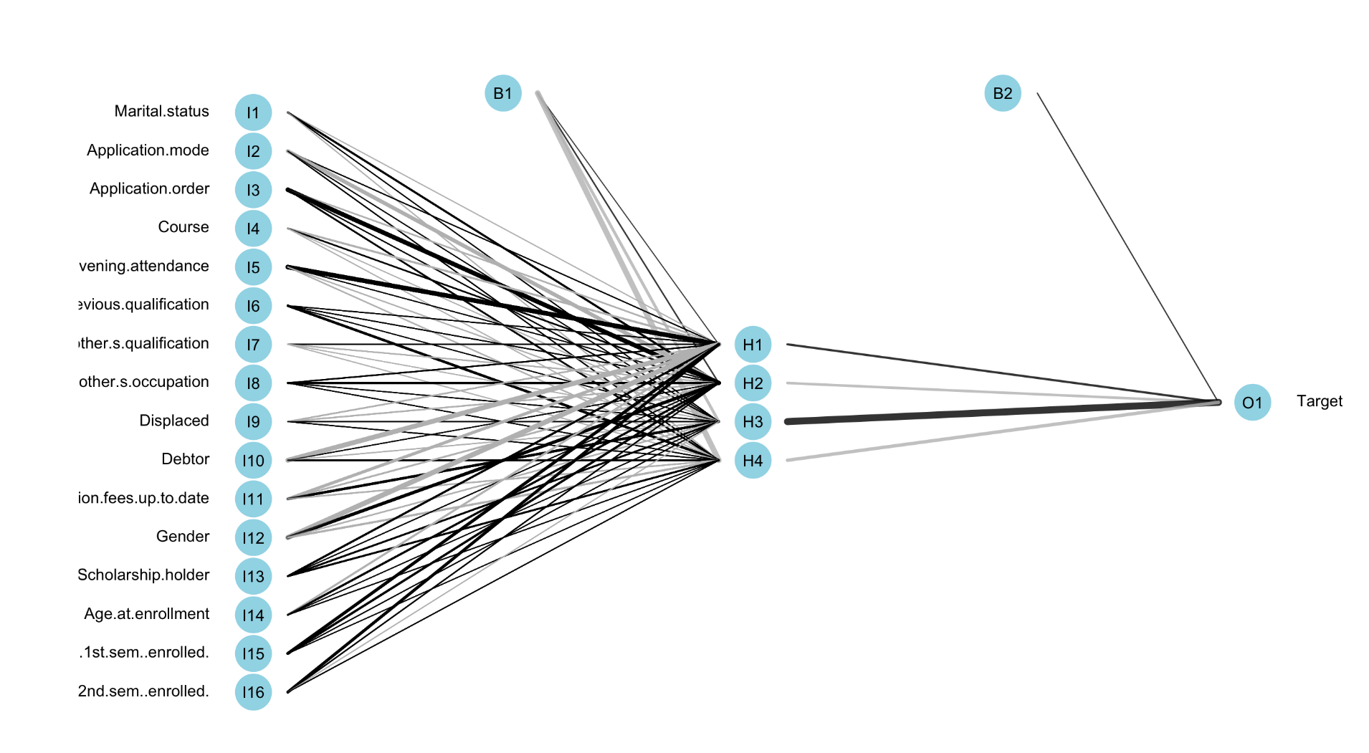
To classify students' enrollment status (graduate, enroll, or drop out) based on various predictors, we developed a neural network model using the nnet package. The dataset was split into training (80%) and testing (20%) subsets to ensure unbiased evaluation, with the target variable encoded as a factor to represent categorical outcomes. A single hidden layer with four nodes was chosen after testing 3, 4, 5, 6, 7, and 8 nodes and testing which minimizes the mse and test error. The model used a weight initialization range of 0.01 to promote stable learning and a regularization decay parameter of 5e-2 to penalize large weights and mitigate overfitting. The logistic sigmoid activation function, inherent to the nnet package, was used to capture non-linear relationships among predictors. To ensure convergence, training was run for a maximum of 1,000 iterations. A 10-fold random split cross-validation approach was applied to ensure robust performance estimates, with results averaged across iterations. Additionally, a confusion matrix provided insights into specific patterns of misclassification, while the network structure was visualized using plotnet. This design allowed for a reliable and interpretable model to address the classification task effectively. The optimization process demonstrated convergence in each fold, as the training loss consistently decreased over iterations.
As a result, the final loss values across folds ranged from approximately 1583 to 1610, indicating consistent model performance. The mean prediction test error across the 10 iterations for our model was 0.2138983 and the mean test prediction accuracy was 0.7877966. If we look at our model, the black thick lines indicate that they are positive weights with higher importance. These variables were scholarship holders, curricular units first semester enrolled, and age at enrollment, which corresponded to the variance important plot.

Conclusion
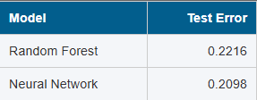
The predictive analysis of whether or not a student is likely to drop out provides valuable insight into if a current student is likely to drop out, as well as what aspects of a student’s background and current academic status are indicators they will drop out. One key predictor for determining if a student is likely to drop out is whether their tuition fees are up to date. The importance of this variable demonstrates that a student’s financial commitment to their higher education gives strong insight into future enrollment. Similarly, the importance of the age of the student at the time of enrollment shows how a student’s background can give insight into their future enrollment status.
For the analysis, the machine learning models: random forest, and neural networks were used for the purpose of classification of students. These models were chosen for multiple reasons. The first is their flexibility in deducing complex relations as there are no immediately clear patterns in the data. The second reason was for their ability to handle data with high dimensionality as many factors were considered for the analysis which could potentially lead to overfitting. After performing cross-validation on the two models, it was found that the neural network had a slightly lower test error rate than the random forest model for classification.
Overall this analysis provides an understanding of what factors may indicate a student will drop out and helps predict whether current students are likely to drop out. Applications of this study could involve probing further into the social and economic factors that correlate to dropping out, or as a preventative measure to identify students deemed at risk of dropping out of the university.

References
GeeksforGeeks. (2023, August 24). Neural networks using the R nnet package. https://www.geeksforgeeks.org/neural-networks-using-the-r-nnet-package/
James, G., Witten, D., Hastie, T., & Tibshirani, R. (2022). An introduction to statistical learning: With applications in R. Springer.
Predict students’ dropout and academic success. Kaggle. (n.d.). https://www.kaggle.com/datasets/thedevastator/higher-education-predictors-of-student-retention/data

